**Name: Soumyadeep Ganguly**

**Roll. No: 24MDT0082**

**Course: M.Sc. in Data Science**

**Assessment 1**

**PMDS506P Database Management systems.**

**Q1. Create a table EMPLOYEE with the following schema. Decide the appropriate datatypes that can be used and construct the table.**

create table EMPLOYEE(

emp_no number(6) not null unique,

e_name varchar(50) not null,

e_address varchar(100),

e_phone number(12),

dept_no number(6),

dept_name varchar(20),

job_id number(6),

salary number(10));

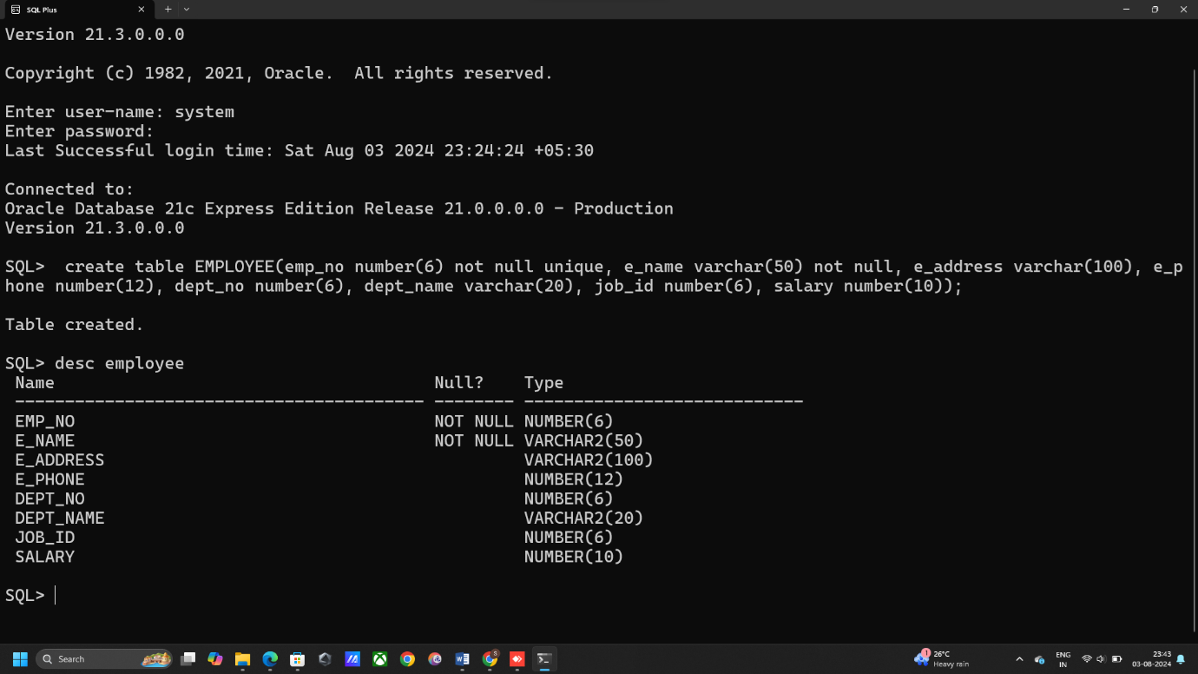

**a. Add a new column; HIREDATE to the existing relation.**

alter table EMPLOYEE

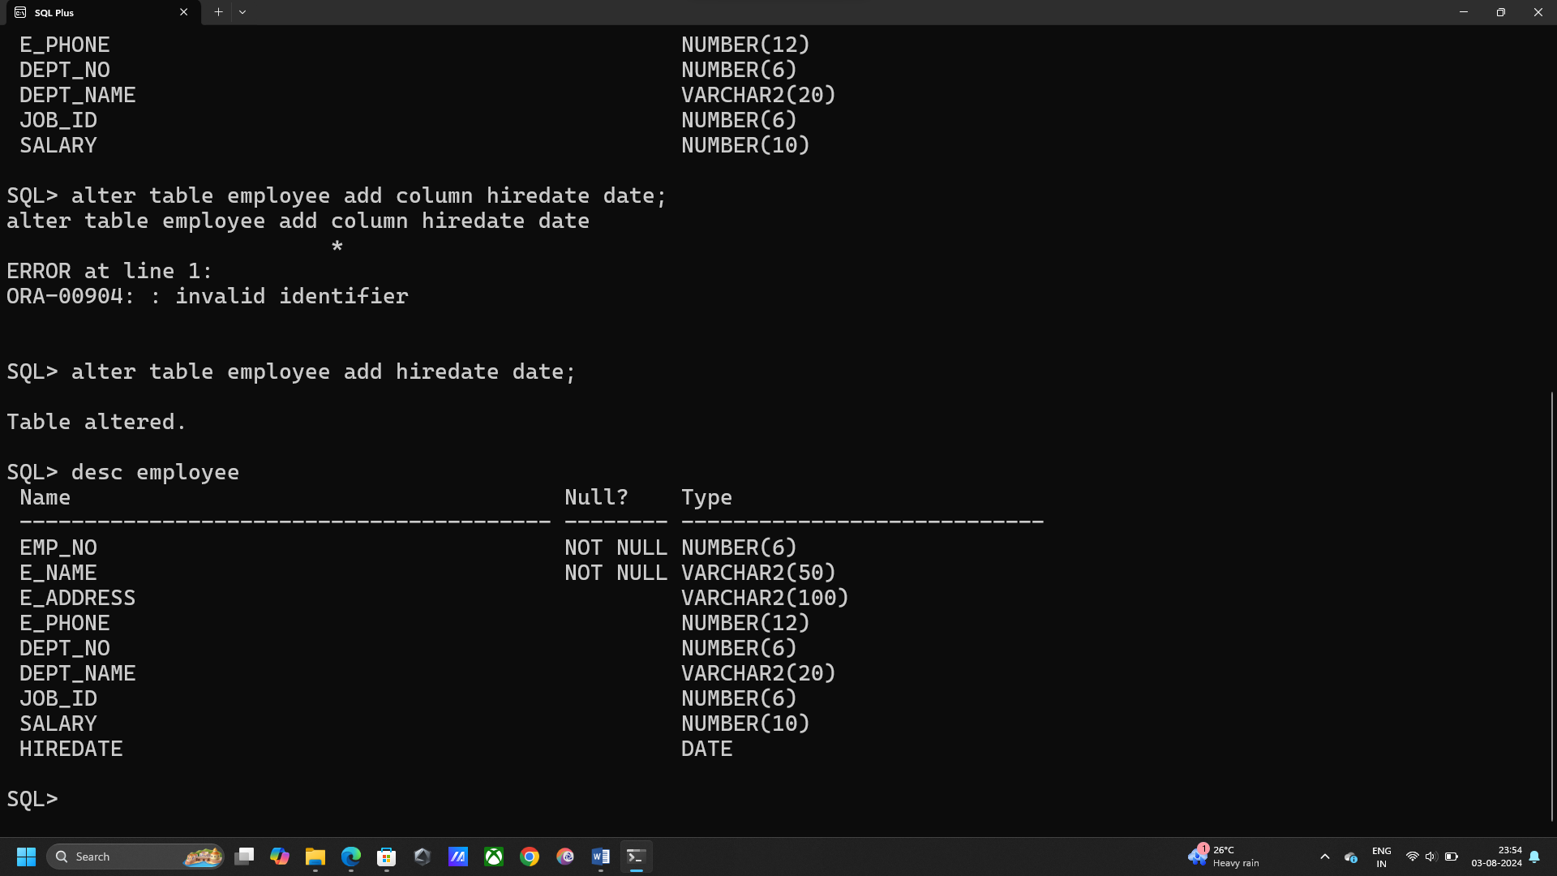add hiredate date;

**b. Drop a column E_address.**

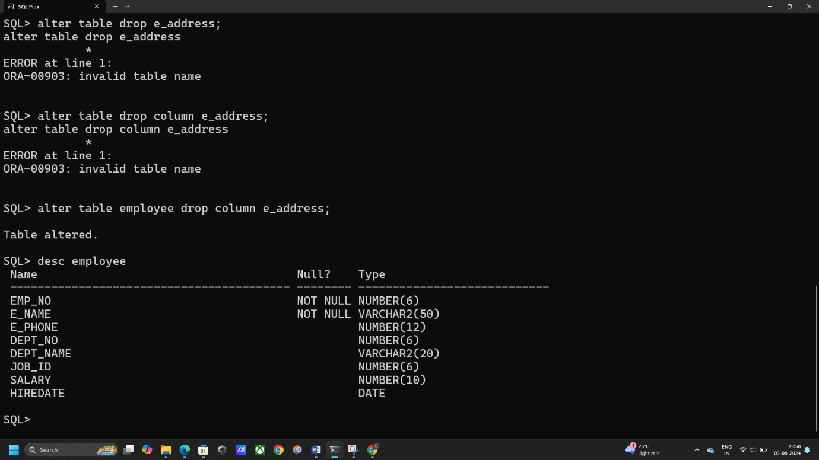alter table EMPLOYEE drop column e_address;

**c. Change the datatype of JOB_ID from char to varchar2.**

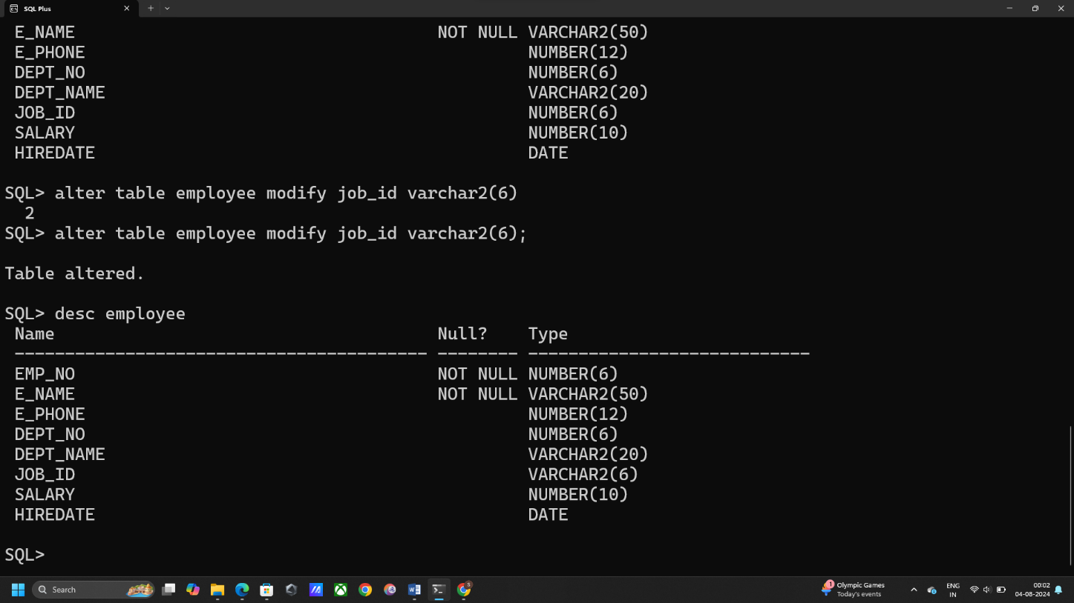alter table EMPLOYEE modify job_id varchar2(6);

**d. Change the name of column/field Emp_no to E_no.**

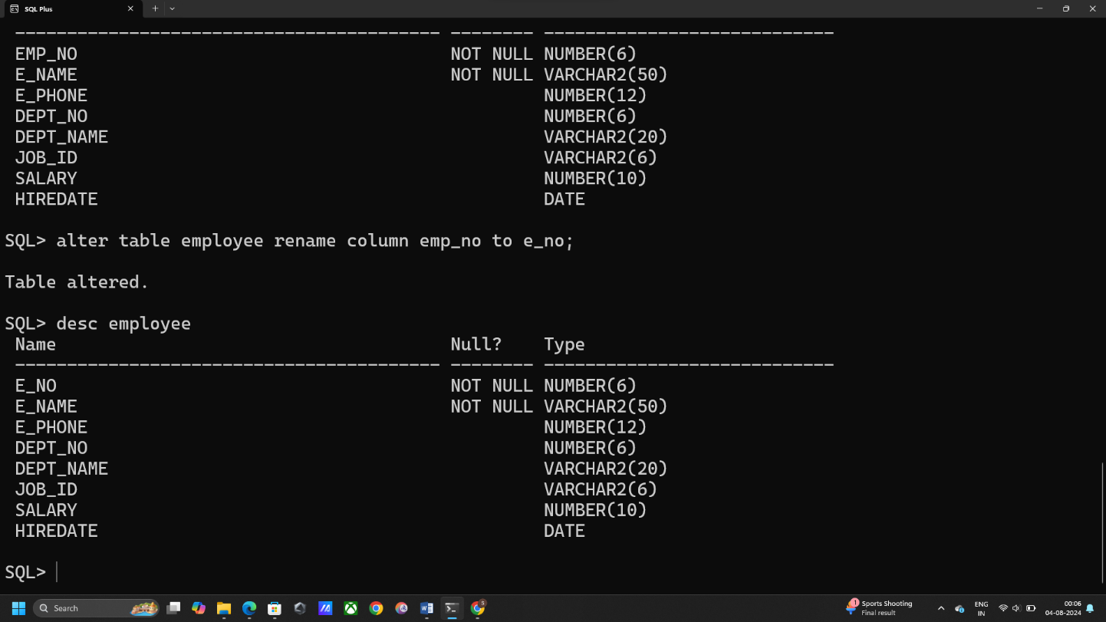alter table EMPLOYEE rename column emp_no to e_no;

**e. Rename the table to OLD_EMPLOYEE.**

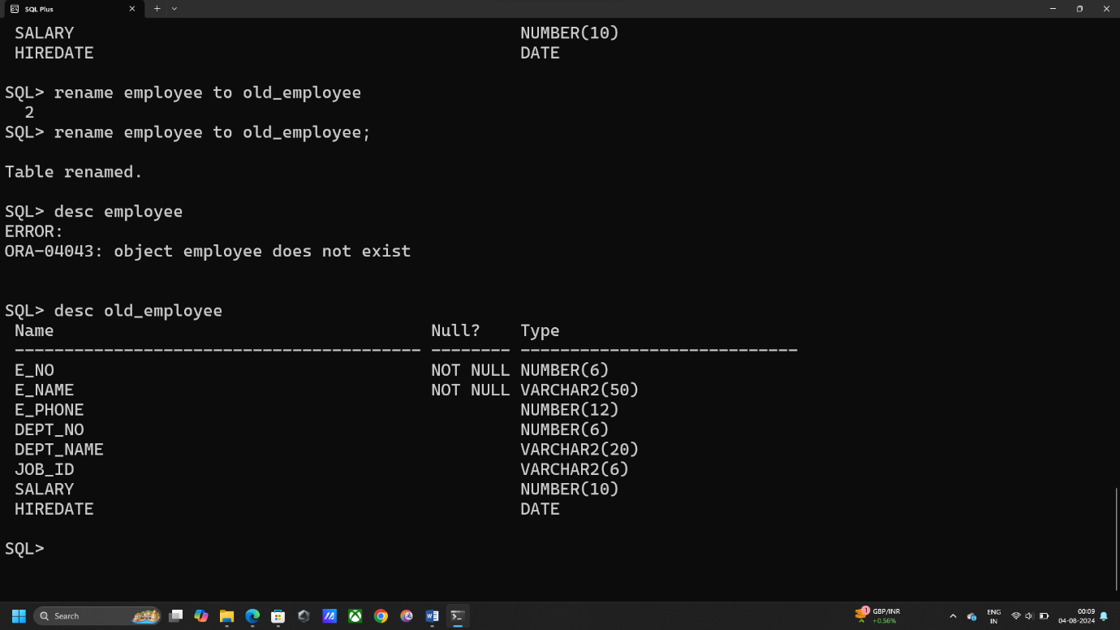rename employee to old_employee;

**f. Drop the table OLD_EMPLOYEE.**

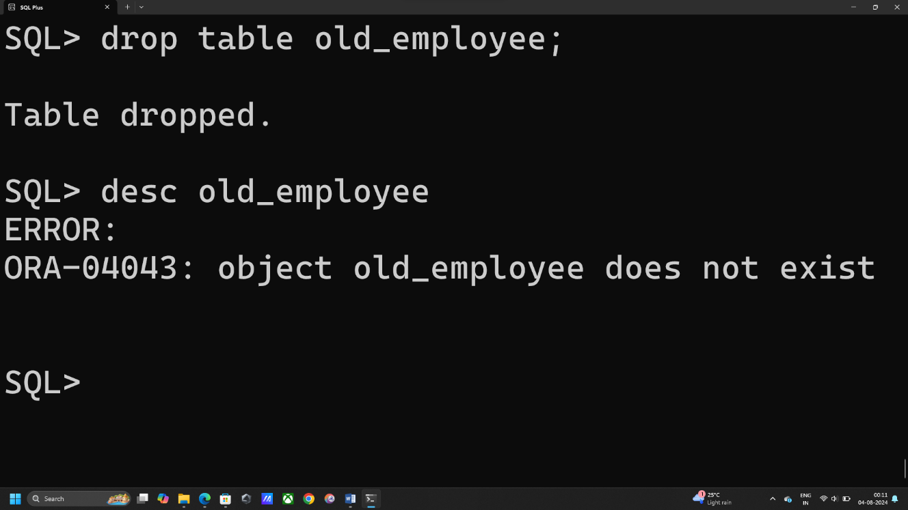drop table old_employee;

**Q2. Create a table EMP with the following schema.**

**(Emp_no, E_name, E_address, E_ph_no, Dept_no, Dept_name,Job_id , Salary)**

create table EMP

(emp_no number(6),

e_name varchar(50),

e_address varchar(100),

e_ph_no number(12),

dept_no char(10),

dept_name char(10),

job_id number(6),

salary number(10));

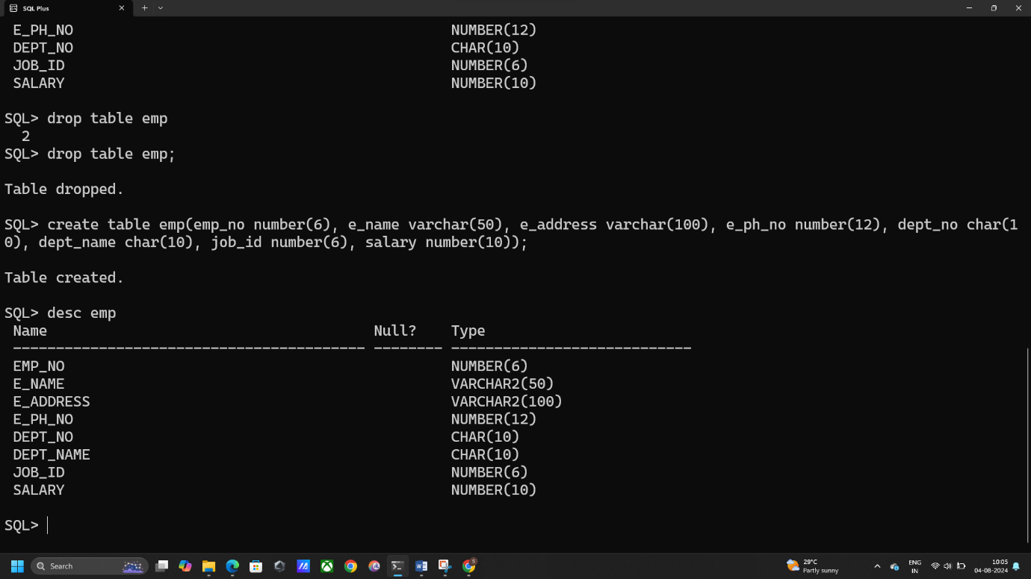

1. **Insert at least 8 rows in the table. (Give the Dept_no as D1, D2 or D3, Emp_no as starting from 1 to 8. Use Dept_name as MAT, PHY or CHY)**

insert into emp values(1, 'Joe Matt', 'ABCD street', 74653645, 'D1', 'MAT', 12, 20000);

insert into emp values(2, 'Robert', 'XYZ street', 84545645, 'D2', 'PHY', 11, 21000);

insert into emp values(3, 'Soumyadeep', 'dfg street', 946785645, 'D3', 'CHY', 12, 20000);

insert into emp values(4, 'Arun Kumar', 'hjg street', 678785645, 'D2', 'PHY', 13, 22000);

insert into emp values(5, 'Amit Majumder', 'iru street', 678745682, 'D3', 'CHY', 12, 21000);

insert into emp values(6, 'Rajib Ghosh', 'WXY street', 98765482, 'D1', 'MAT', 10, 19000);

insert into emp values(7, 'Souvik Das', 'UDG street', 985467824, 'D1', 'MAT', 12, 20000);

insert into emp values(8, 'Rohan Mukherjee', 'TYR street', 785463526, 'D3', 'CHY', 15, 23000);

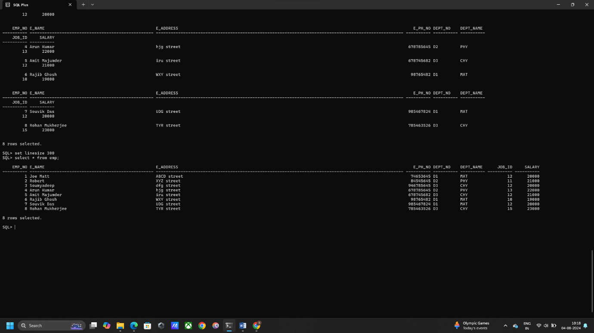

1. **Next record in the table should be entered in an interactive way.**

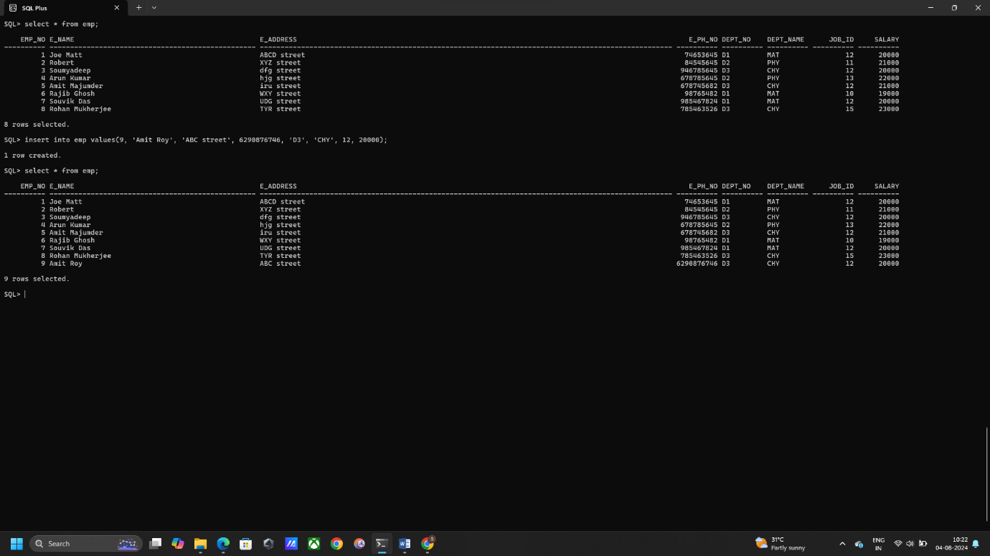insert into emp values(9, 'Amit Roy', 'ABC street', 6290876746, 'D3', 'CHY', 12, 20000);

1. **Display the record of each employee who works in department D2.**

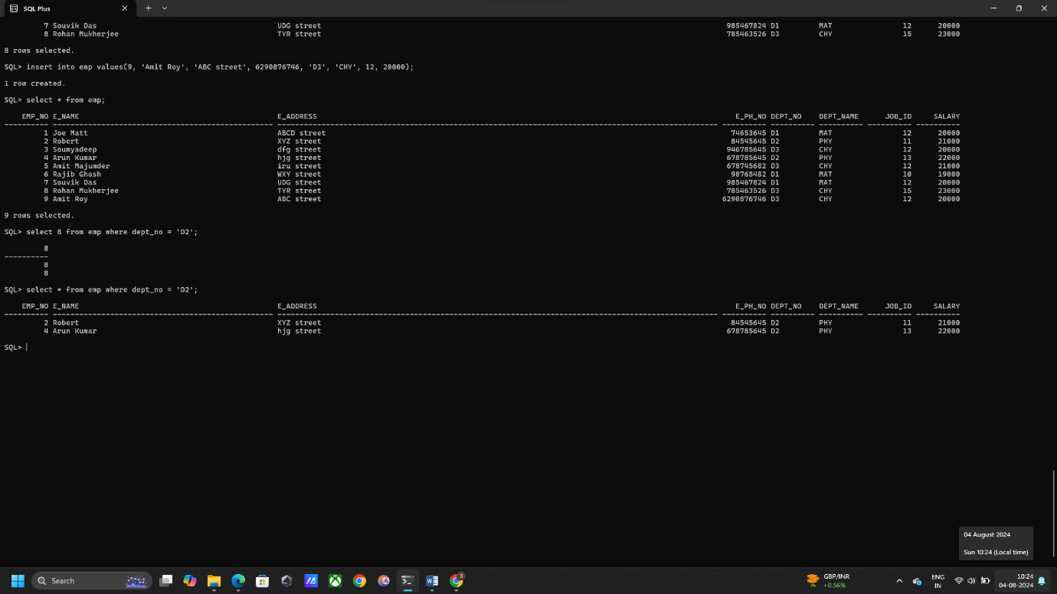select * from emp where dept_no = 'D2';

**d. Update the E_ph_no of Emp_no - 2 with current E_ph_no as 9.**

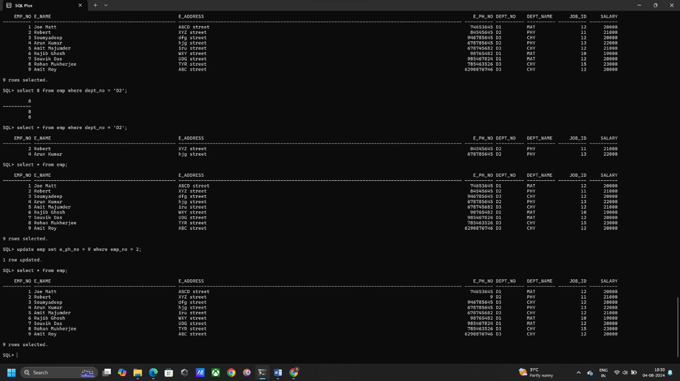update emp set e_ph_no = 9 where emp_no = 2;

**e. Display the details of Employee who works in department MAT.**

select * from emp where dept_name = 'MAT';

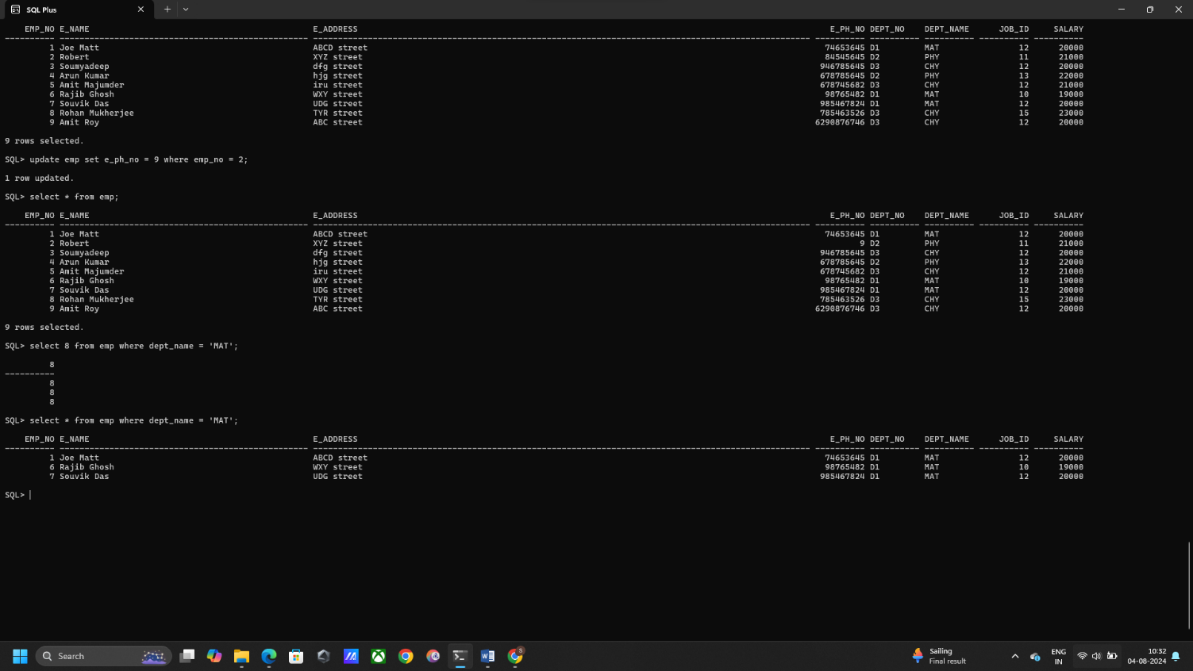

**f. Add a new attribute email_id and add email ids for all the employees in the table.**

**Add attribute:** alter table emp add email_id varchar2(20);

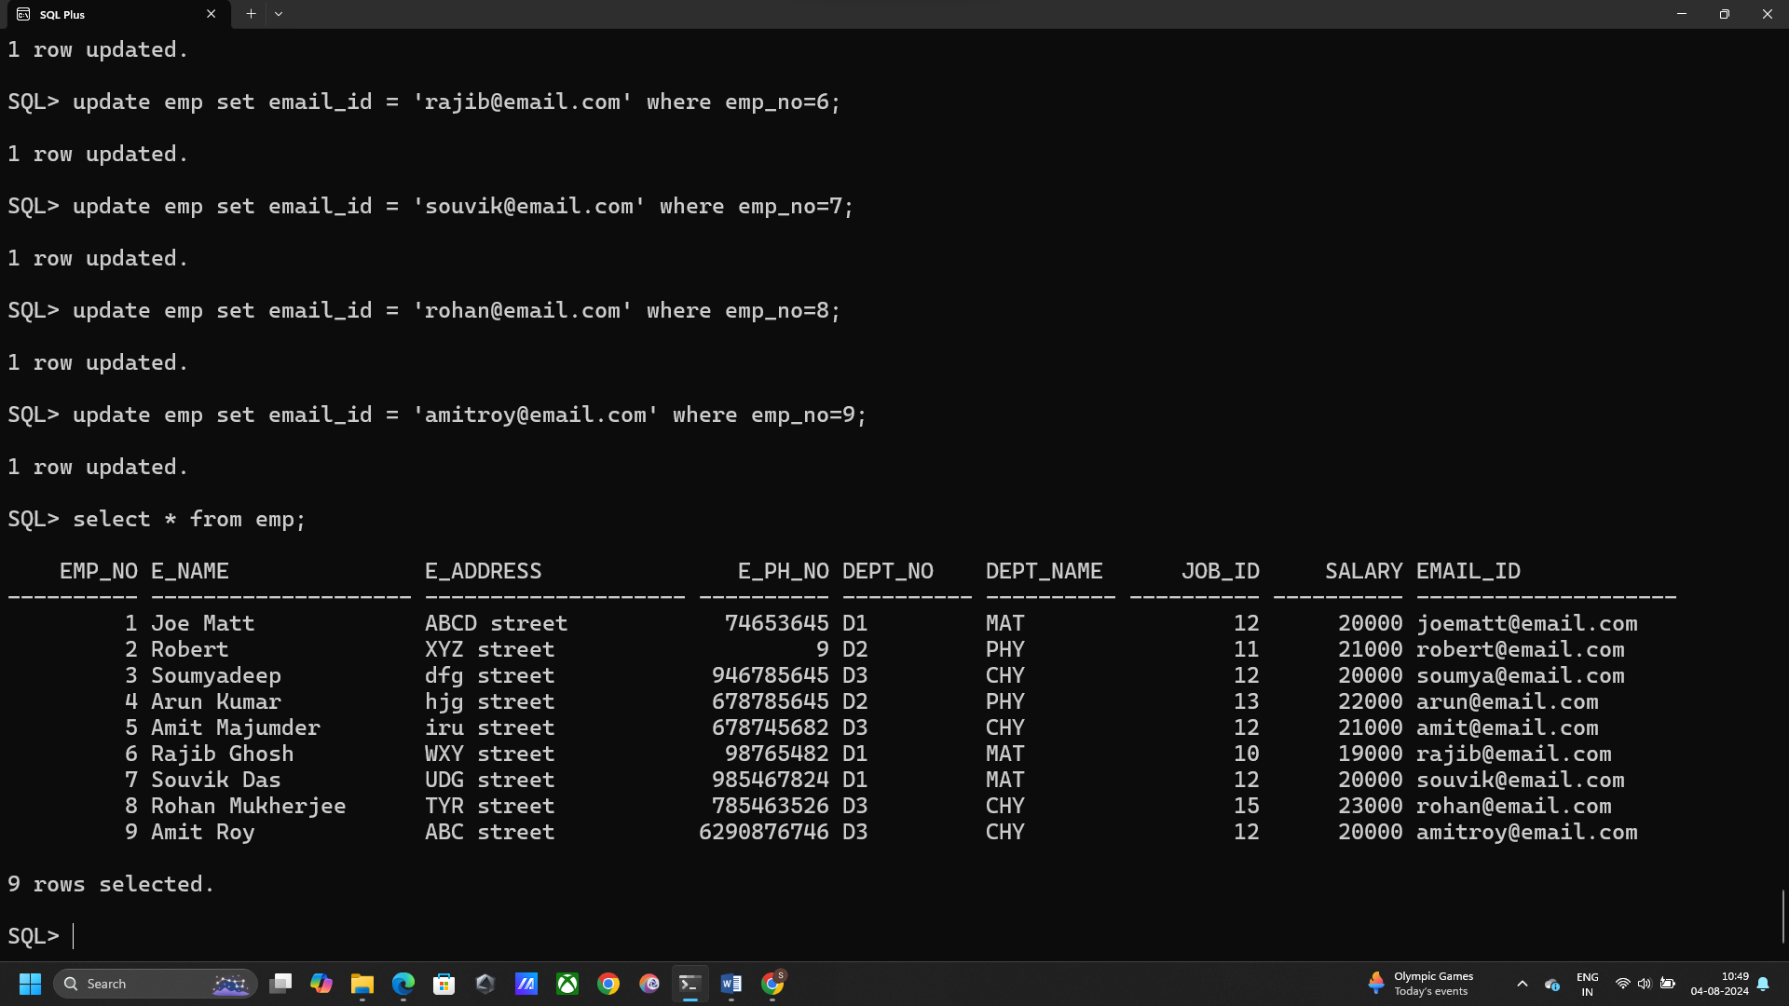**Add Data:** update emp set email_id = 'rajib@email.com' where emp_no=6;

**g. Delete the email_id of employee with Emp_no = 4.**

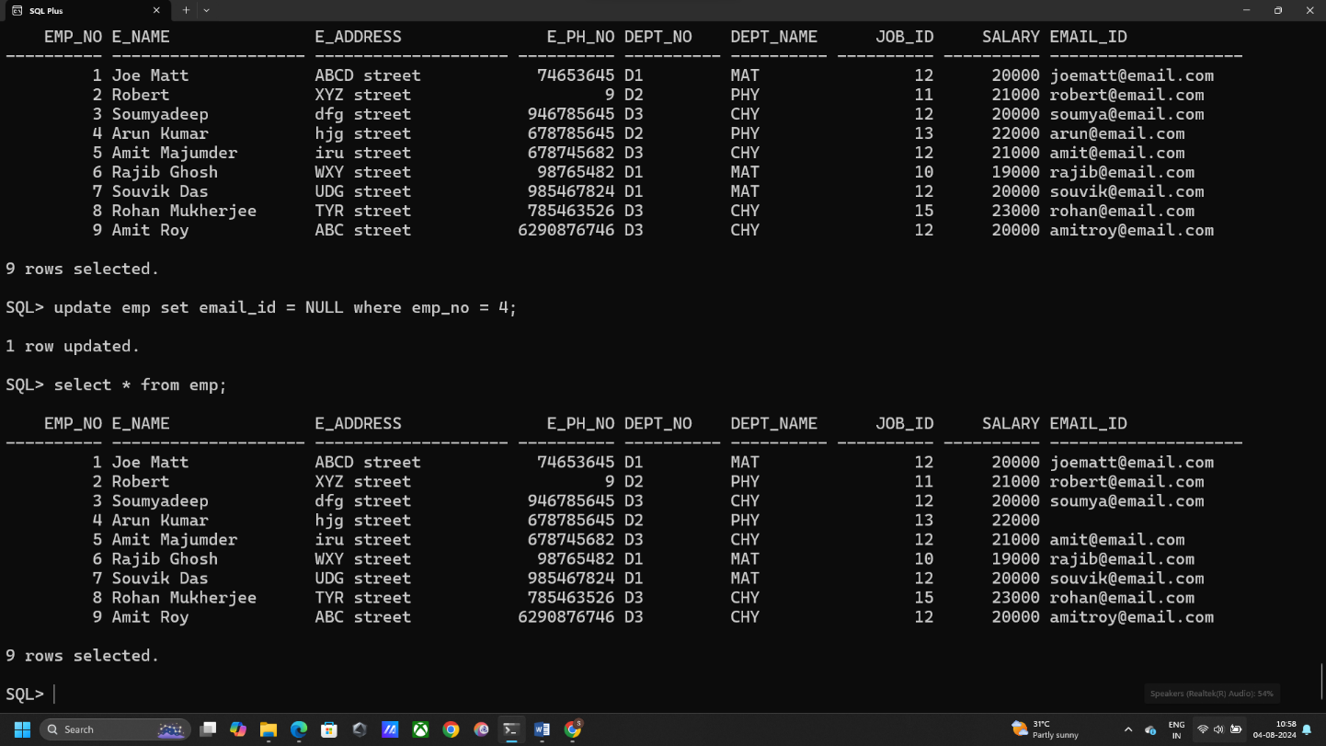update emp set email_id = NULL where emp_no = 4;

**h. Display the complete record of employees working in PHY Department.**

select * from emp where dept_name = 'PHY';

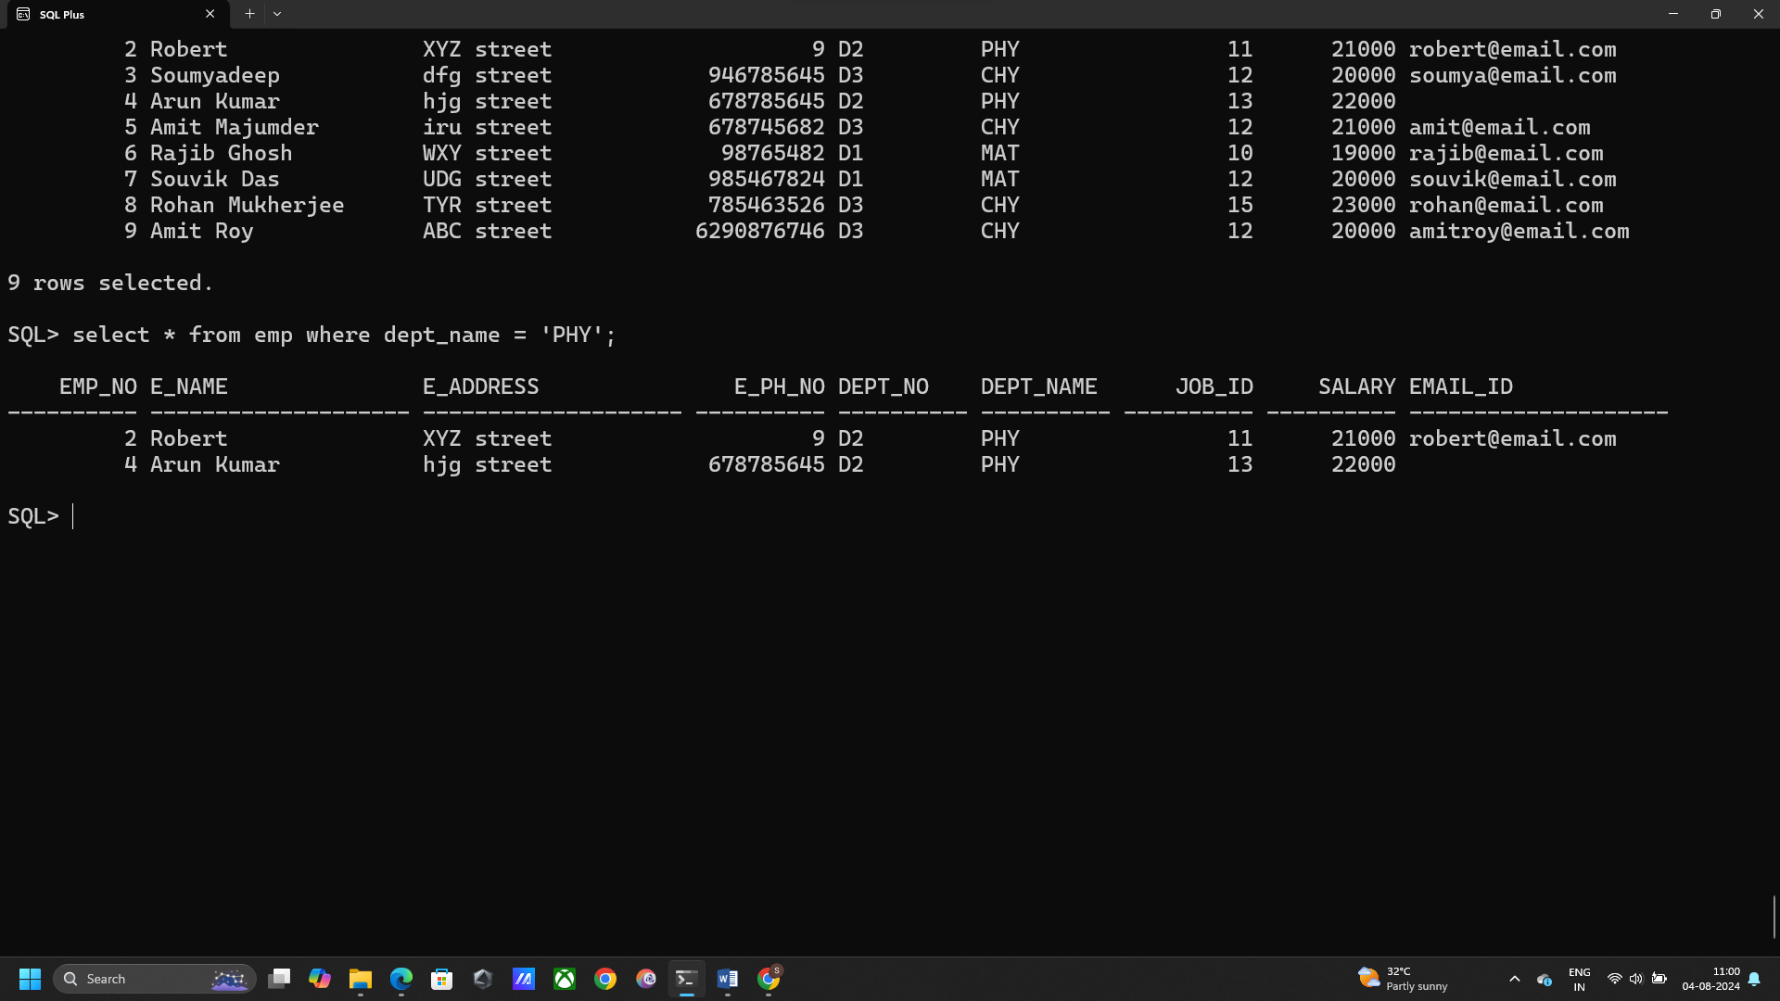

1. **Display all the employee with salary less than 25000.**

select * from emp where salary < 25000;

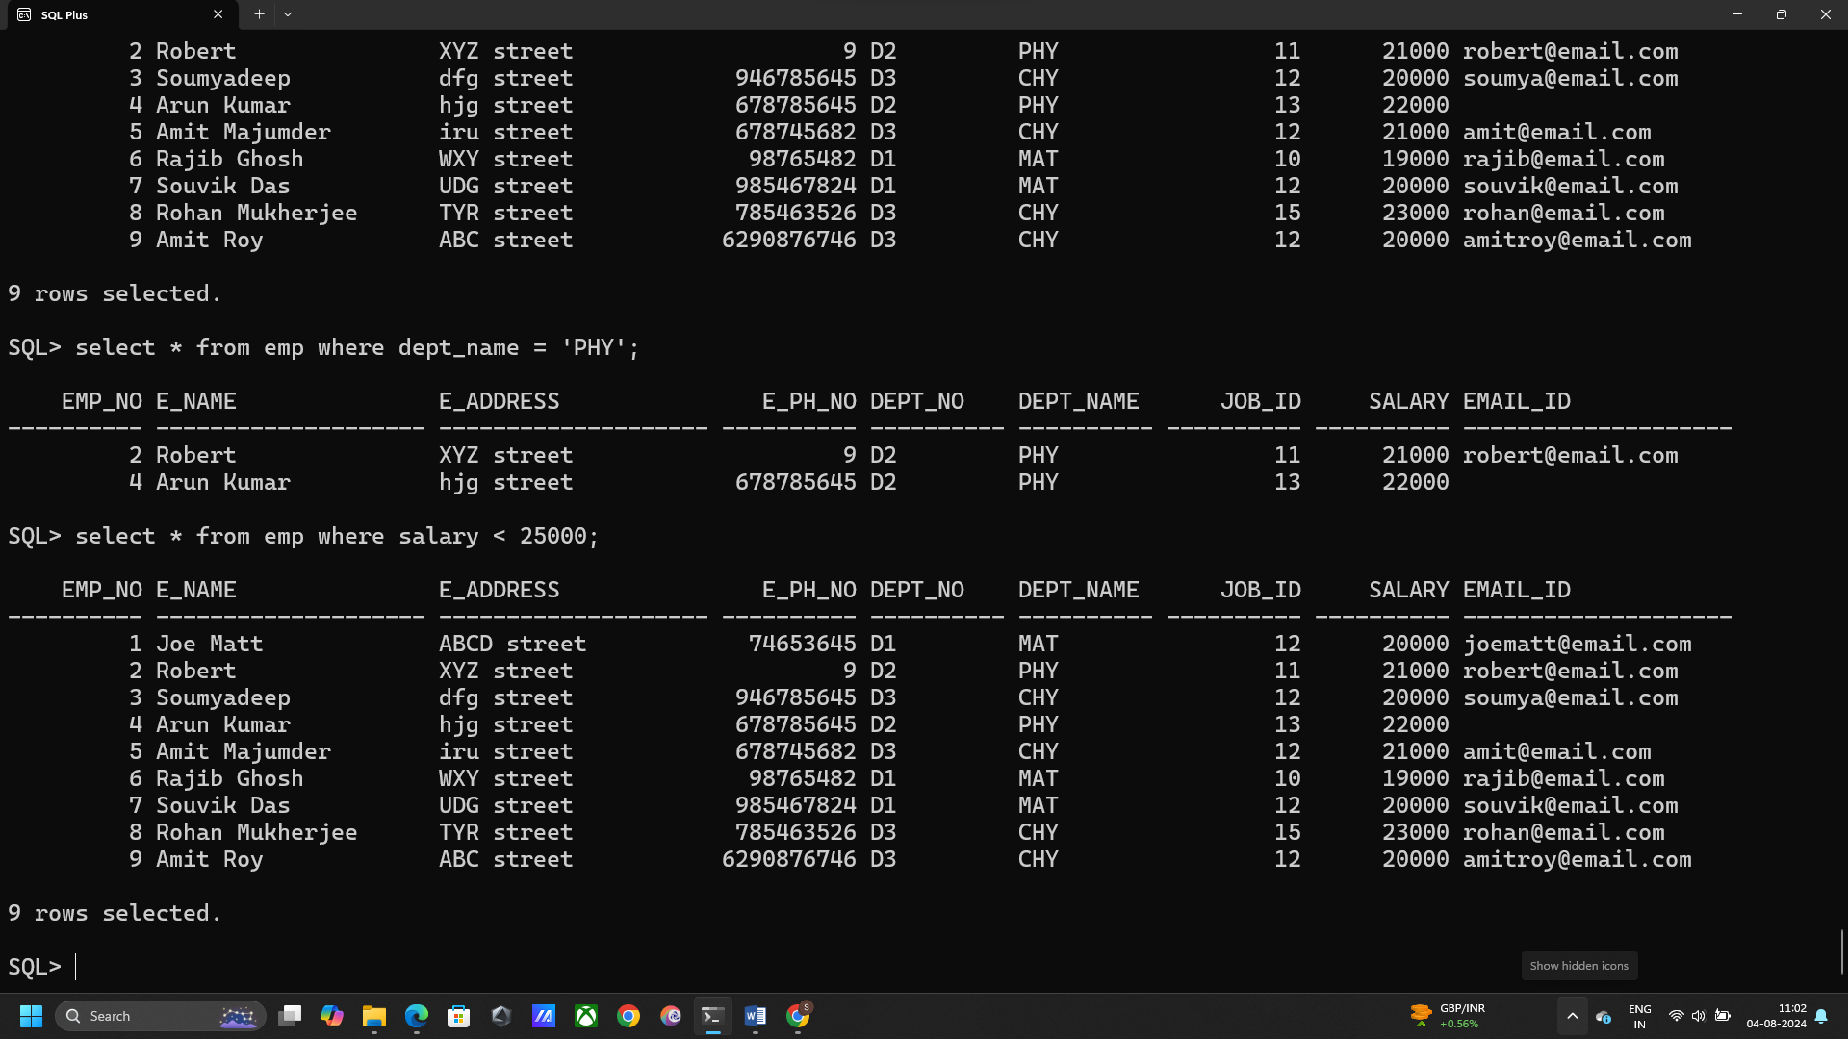

**j. Increment the salary of all the employees in the MAT department by 15%.**

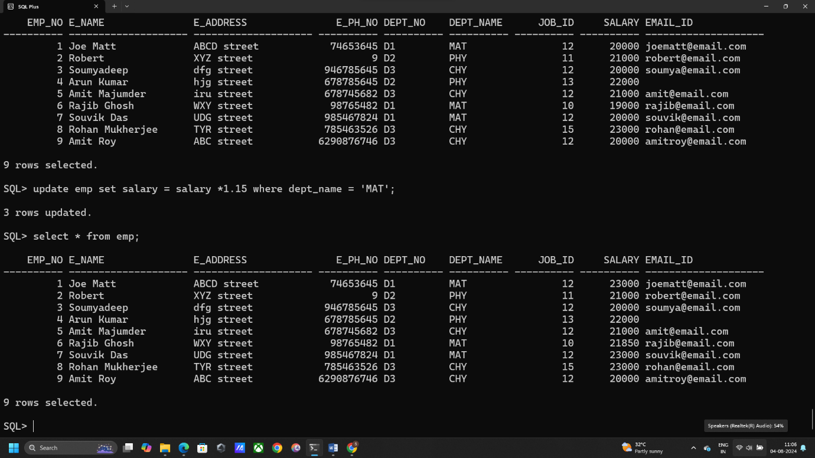update emp set salary = salary *1.15 where dept_name = 'MAT';

**k. Display all the information of EMP table.**

select * from emp;

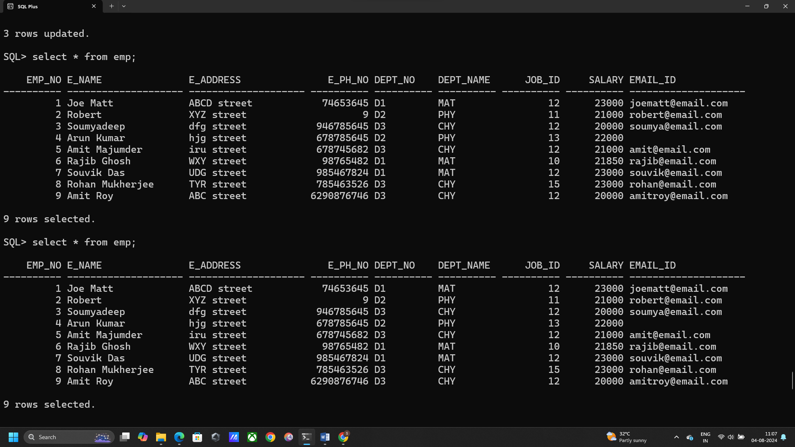

**Q3. Create a table EMPLOYEES (columns and datatypes given in the table below), and insert the following values in the table. After inserting all the values display the employees table.**

**Create Table:** create table employees(dept_id int, id number(5), first_name varchar2(50), last_name varchar2(50), salary number(6));

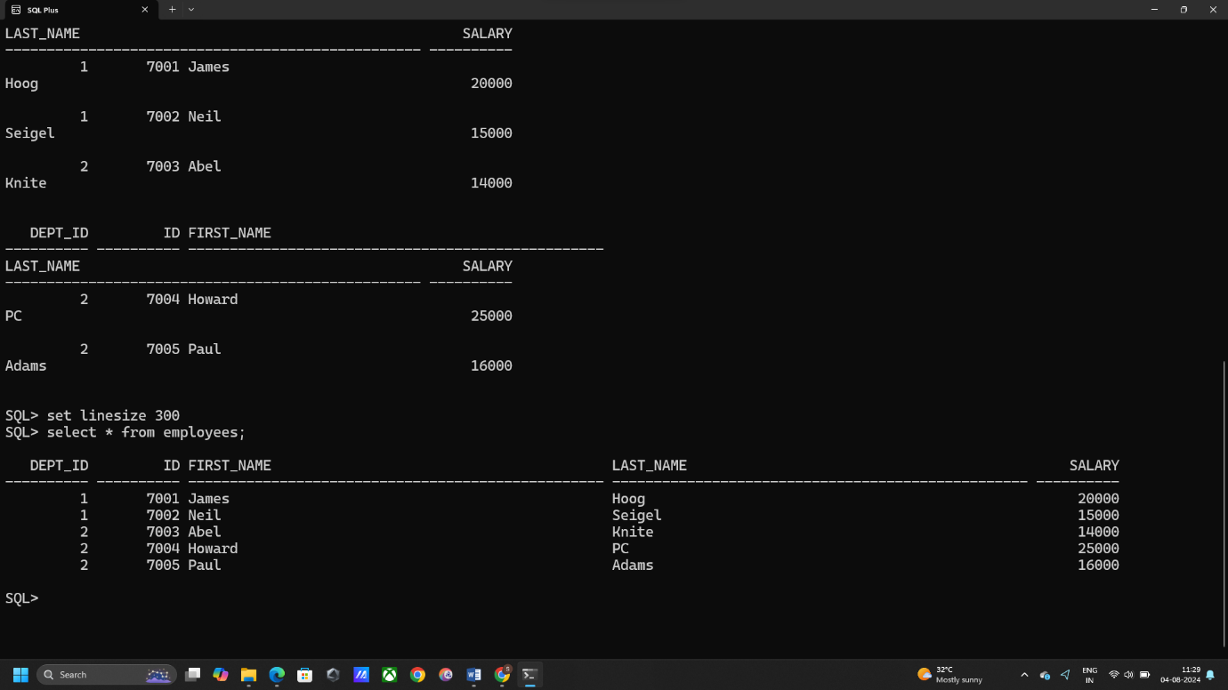**After Data insertion:**

**Commit data:** commit;

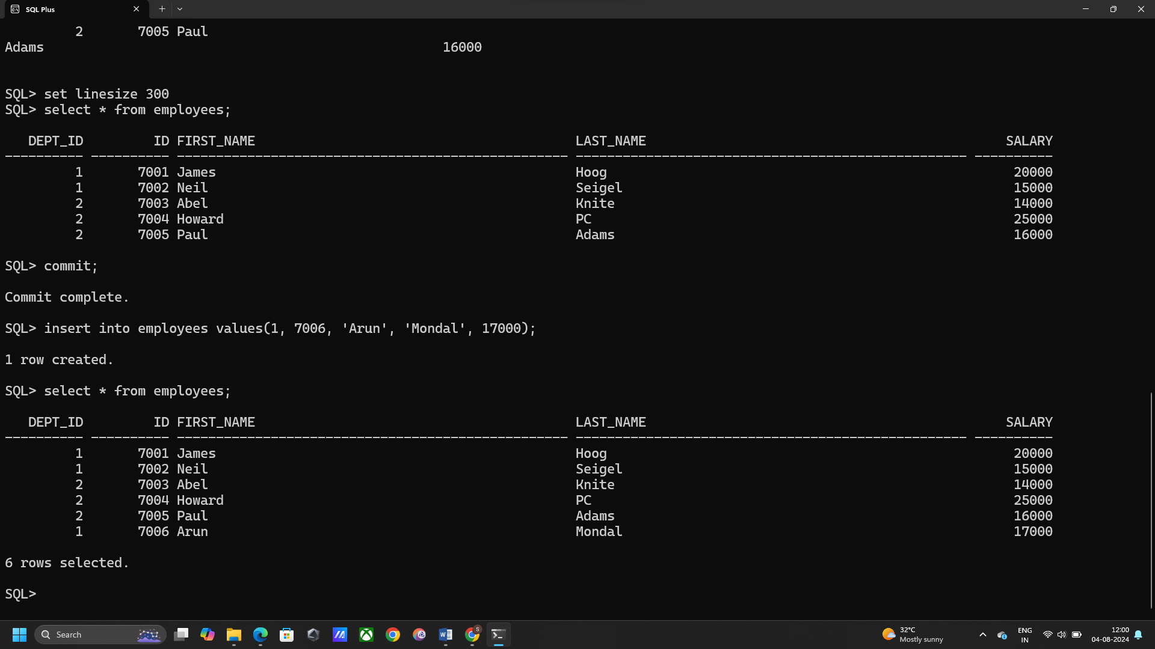**Add new data:** insert into employees values(1, 7006, 'Arun', 'Mondal', 17000);

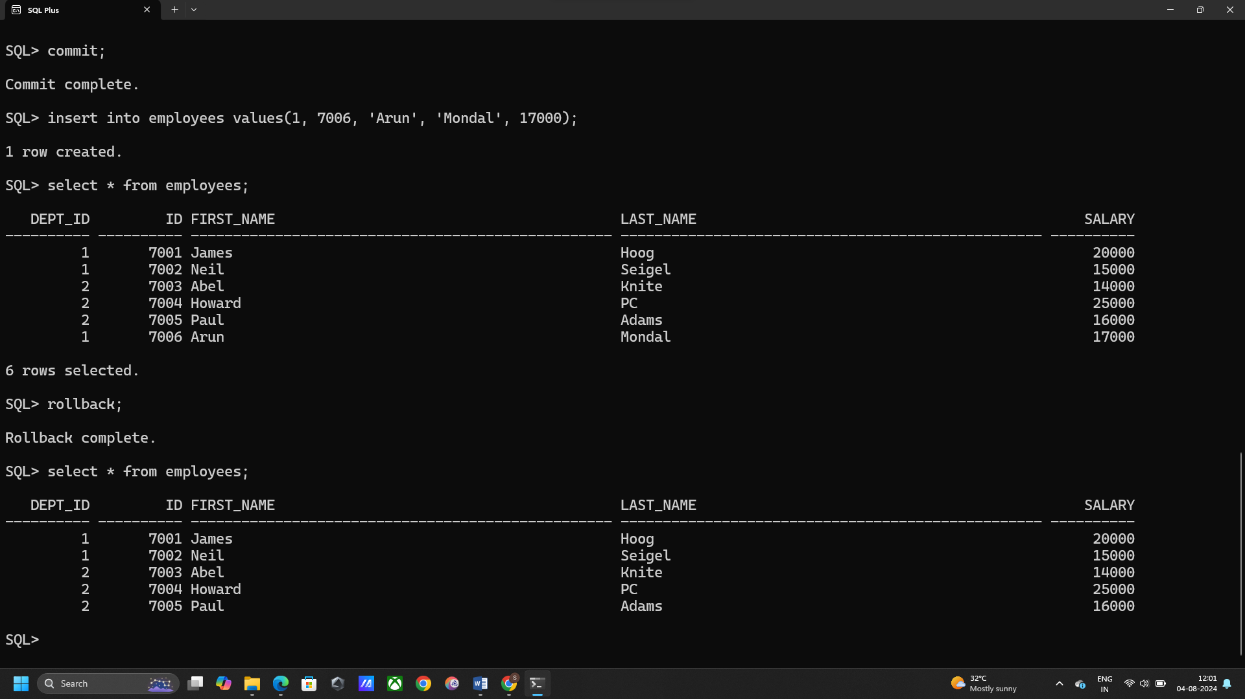**Rollback table:** rollback;

**Add 2 rows:**

insert into employees values(1, 7006, 'Amit', 'Trivedi', 18000);

insert into employees values(2, 7007, 'Rahul', 'Sharma', 20000);

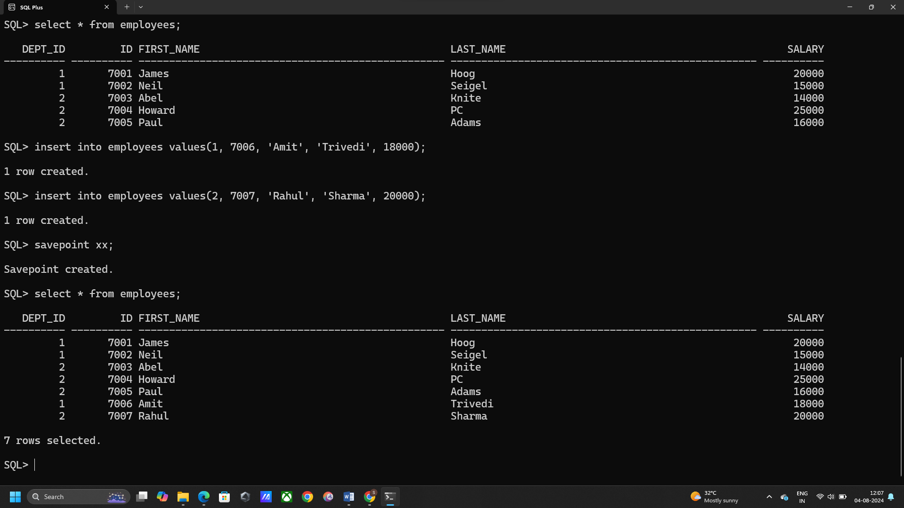**Create Savepoint:** savepoint xx;

**Add another record:** insert into employees values(1, 7008, 'Soumyadeep', 'Ganguly', 22000);

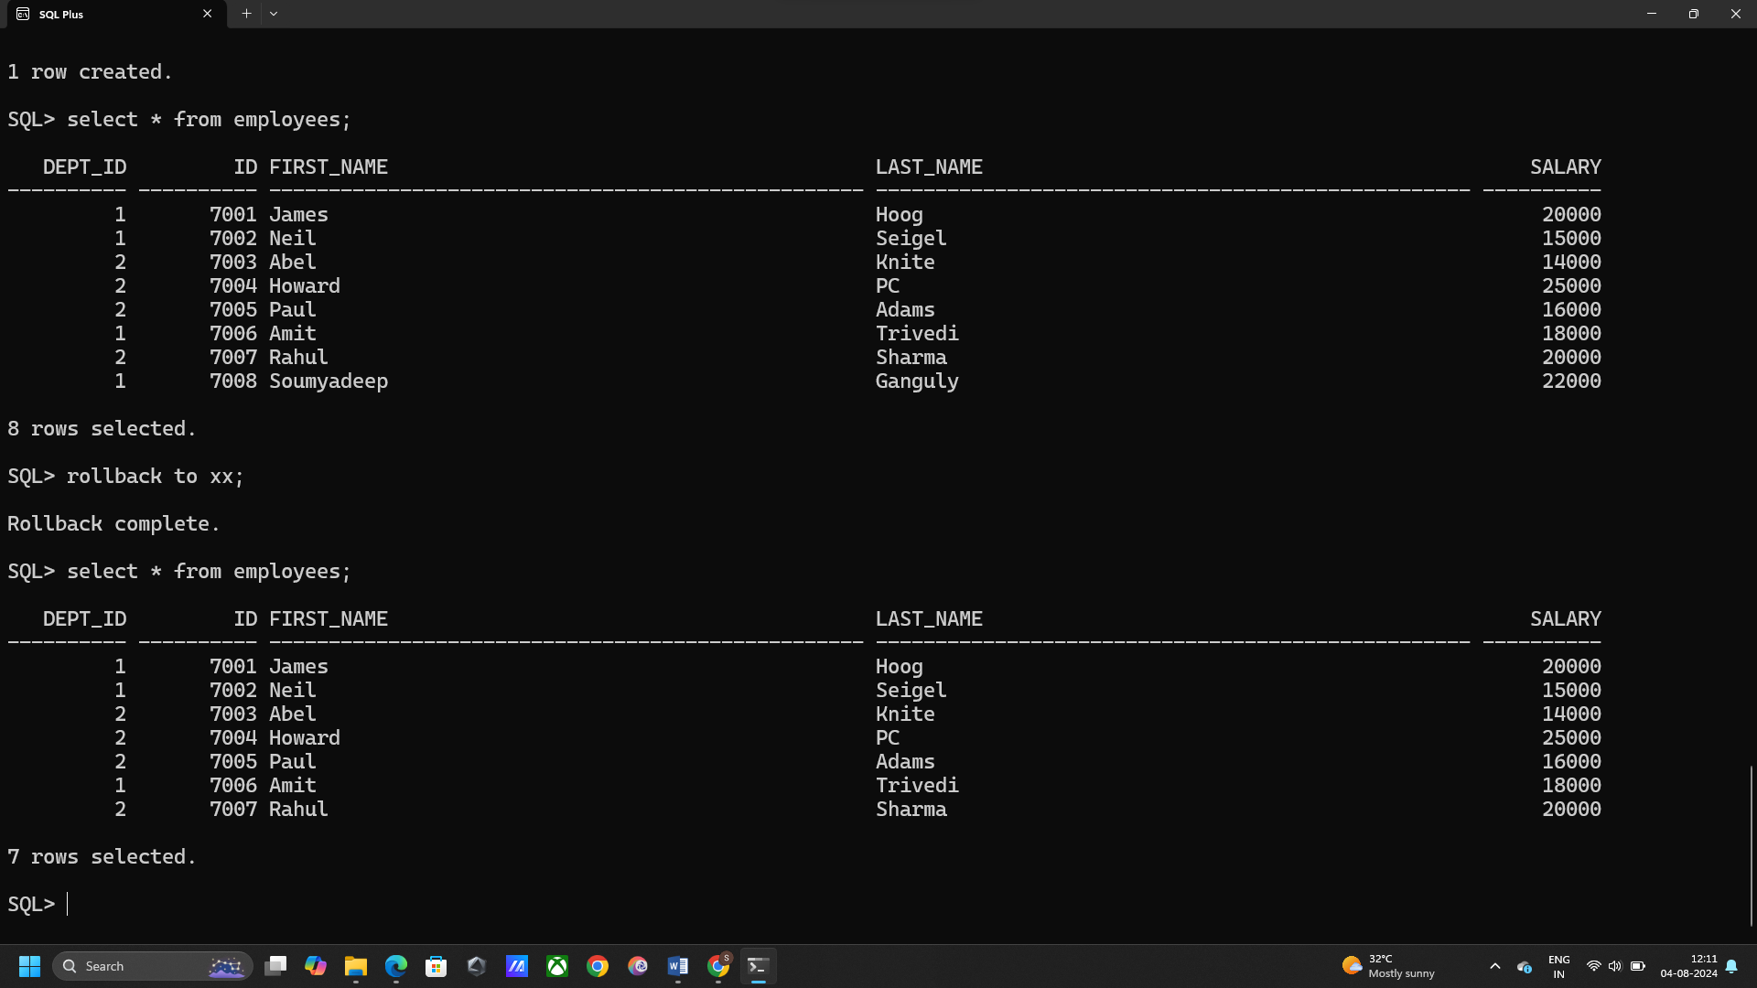**Rollback to savepoint XX:** rollback to xx;